Assignment 3 – Visitor Register Digitization
Problem
Paper visitor book → hard to search.
Task
- Create visitor entry program
- Store name, company, whom to meet
- Search by date
Skills
- dictionaries
- search
- basic reporting

INTRODUCTION:
A Visitor Registration System is used to record and manage information about visitors entering an organization. Maintaining a proper visitor log helps in ensuring security, tracking visits, and managing appointments efficiently.
This implements a console-based Visitor Registration System using Python, where users can add visitor details, store them date-wise, and search visitor information by date. The system uses basic programming concepts such as dictionaries, loops, and conditional statements to provide an easy and effective solution for visitor management.
OBJECTIVES:
- To develop a simple and user-friendly visitor management system.
- To store visitor details such as name, company, and the person to be met.
- To organize visitor records based on visit dates.
- To allow searching of visitor details by a specific date.
- To reduce manual record-keeping and improve data accuracy.
- To demonstrate the use of Python data structures like dictionaries and lists.
- To provide a menu-driven program for easy interaction.
SKILLS:
Dictionaries: Used to store visitor details with dates as keys.
Search: Helps find visitor records for a specific date.
Basic Reporting: Displays visitor details in a simple, readable format.
ALGORITHM:

1. Start

2. Initialize Visitor Register
- Create an empty dictionary named visitor_register
- This dictionary stores dates as keys and visitor details as values

3. Display Menu
Show options:
- Add Visitor
- Search by Date
- Exit

4. Read User Choice

Accept the menu option selected by the user

5. If Choice is Add Visitor
- Read visit date (YYYY-MM-DD)
- Read visitor name
- Read company name
- Read person to be met
- Store visitor details in a dictionary

6. Store Visitor Data
- If the entered date exists in visitor_register, append visitor details
- Else, create a new date entry with the visitor details

7. Display Confirmation
- Display message confirming visitor added successfully

8. If Choice is Search by Date
- Read the date to be searched
- Check if the date exists in visitor_register
- If yes, display all visitors for that date
- If no, display “No visitors found” message

9. If Choice is Exit

Display exit message

Terminate the program loop

10. Handle Invalid Choice
Display error message for invalid input

11. Repeat Menu
Return to Step 3 until Exit option is selected

12. Stop

FLOWCHART:
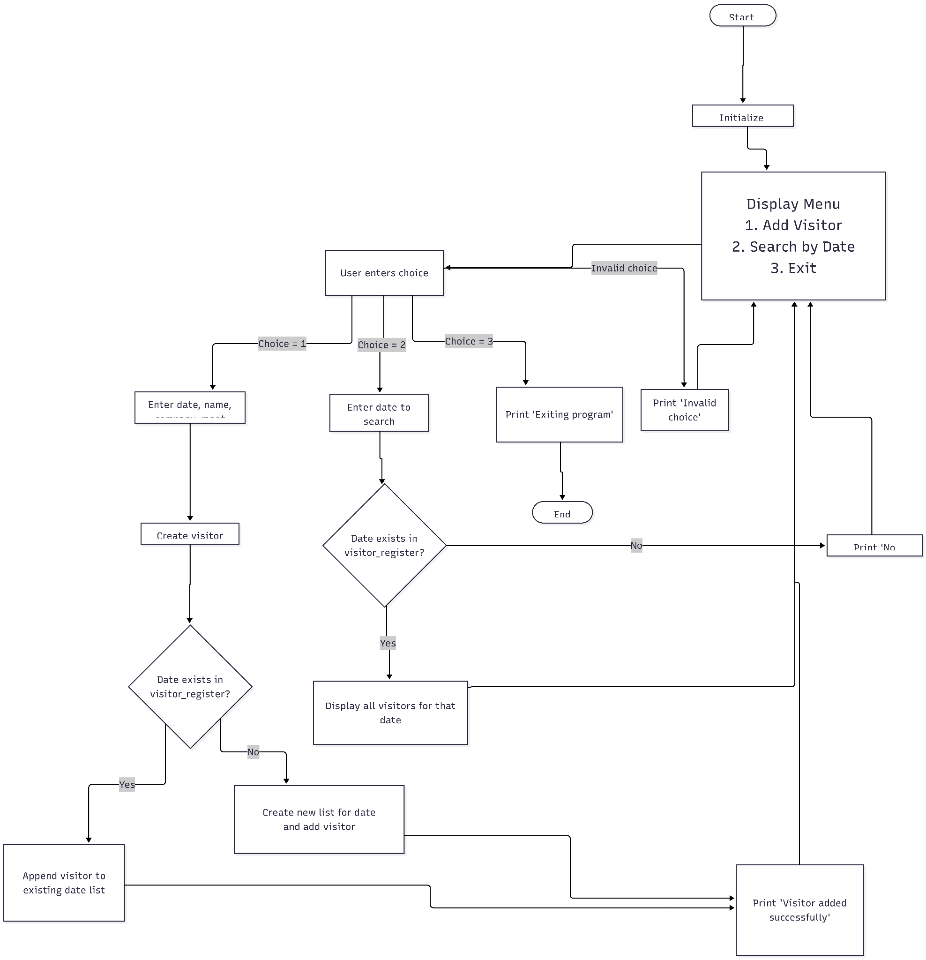
CODE IMPLEMENTATION: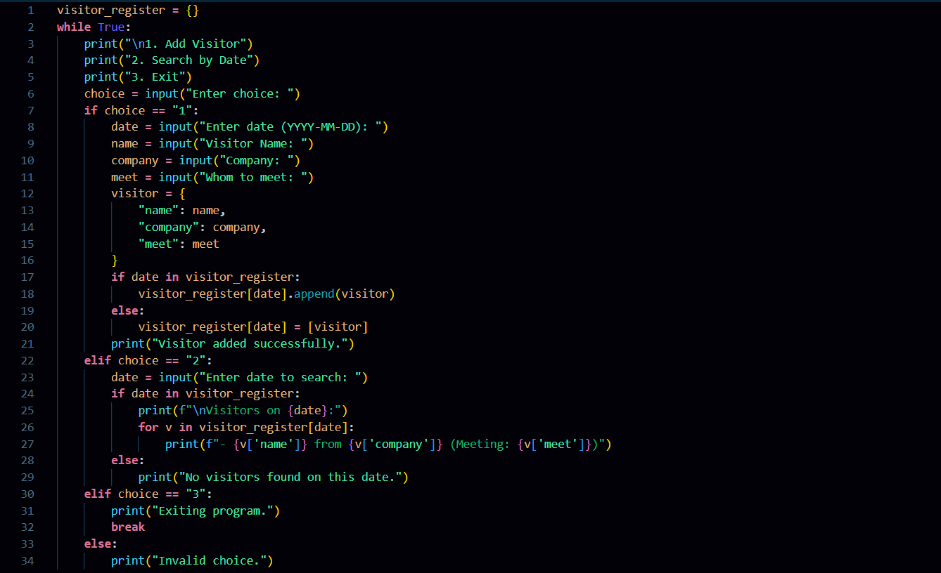
OUTPUT:
